Thursday Renju Class in 5lin.

- 教育訓練組 對 ○助教
Opening i6.

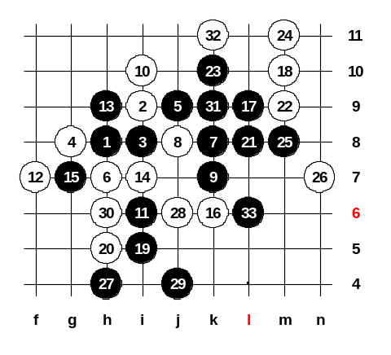
Jan 27 23:18
Hello everybody! Welcome to learn renju!
The 4-g8 is our first move to study today.
And then we will look 4-h7 and 4-j7.
Last week I told about 5-h7, it is very powerful and black wins no problem. Does anyone of you know, where is another 5th move here? If you don’t know, you may try to guess :))
Lets see who first can guess another 5th move ^_^
The j7 is ok, possible, but not the best. 萬盤棋 is right, j9 is correct! Now... black will attack on the right or lower side after this 5th move. We will show you the example black development. White best move now is 6-h7 of course. Tell me the 7th move please. Yes yes, k8 indeed. ^^ If 7-i6 then white can win with 8-f7. Lets continue with strongest white defense moves. 8-j8. White has got two lines on board, black must continue attacking by blocking one of the lines. The 9-k7. White uses the same style: blocking black line and making its own line. The 10-i10. And black uses the same style again, blocking whites and attacking self. The 11-i6. And now, white has no good defense move. Simple block here is useless, black is too strong. The best way for white here is to use the power of open white line and fill the board with some stones and hope that it will help in defense. So white will play threes to f7 and i7, no other choice. But it is hard to choose any good 16th move here. White activity is dead, now white must only defend.
I believe 16-k6 may be the strongest defense. In most cases, taking the forbidden point self is the strongest defense for white. Can anyone guess the black next move? How to continue attack? The m9, maybe interesting... Yes, L9 is the right move!
Black's idea is to use that three at L9 to bring the power to the right side, and then continue with k10. So, if white defends 18-j7 then 19-k10 must be very easy win. So, of course white must play 18-m10, trying to defend against k10 danger. Now, this is useful lesson for you: If you see that the power is not enough to win, don’t continue attack there. If you can see that k10 is not strong enough to win, don’t put it there!
You have to develop attack more carefully by using the extra force from below.
The 19-i5 is the key move for black win! Now, black has power below, white must put a stone below too. The best is 20-h5. Black uses the additional force now at L8, now the point k10 becomes strong again ^^ Of course white will try m9 now, but too late, black can already connect lower side power with k10 point. The 23-k10, black sure wins! Look at the harmony of the black attack - first uses to lower side (i5) to make the upper side (k10) alive, and then uses the force of k10 to connect lower side again and win. I will show the black win here. The 24-m11. And black final attack will begin. The 33-L6 is enough, everyone can see the coming win at n8,m7. Do you have any questions?
If 24-L10 then 25-m8, 26-n7 and black has VCF above (just don’t forget the right sequence in playing that VCF) j11, L11, k11 is the sequence.
Haha.. forgot.. first is 25-h6, then next moves are same as I said before. ^^
25-h6, 27-m8, 28-n7, 29 begins VCF.
As you may see, this 5th is more difficult than the other 5th, but is still sure win! ^_^
Do you have any other questions about this 5th move? OK, I want to give you homework about this 5th move, and then, if we have time, we can begin to look another 4th move today and continue it next time.

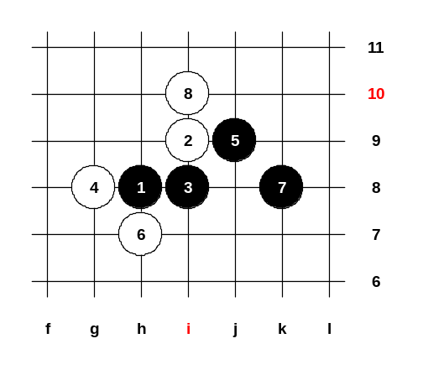
Jan 27 23:22
This is your homework, can any one of you find black sure win attack here? ^_^
So, you must find the right winning sequence from move 9. Please write your answers to game discussions. Other days I will come back online and look if your answers are correct or not.
Ok, we may close it now, and I will show you the beginning of other 4th move tonight.

萬盤棋 : Jan 28 20:06
I try to find the correct moves that black sure win here! I have do my best but still can't find it !:(
Who can offer some suggestions for me to find it ? :( It would be grateful! ^__^

ErazorX : Jan 28 22:37
Please correct me if I am wrong: 11-j8, 12-L8, 13-j6. If 14-j10 then 15-i6. If l4-j7 then 15-i7. If 14-j5 then 15-j7, 17-i6. =〉Black has sure win.

萬盤棋 : Jan 29 01:42
To: ErazorX
I have already know this way when the first time I try it! But the trouble is the move "j7"! I try to attack but black not sure must be win here! I think maybe the moves I played are wrong in here! Please tell me what moves shall I play! Thank you ! ^__^

ErazorX : Jan 30 20:12
Sorry, my mistake @_@ No sure win for black after 14-j7, 15-i7, 16-k5, 17-k9, 18-L10, 19-k10, 20-k7. Any further suggestion is greatly appreciated :)

Mickey : Feb 2 16:42
Nobody can offer the correct answer? :(

教育訓練組 : Feb 3 21:48
I will post the right answer of the problem in this class today, February 3. ^^

Jan 27 23:23
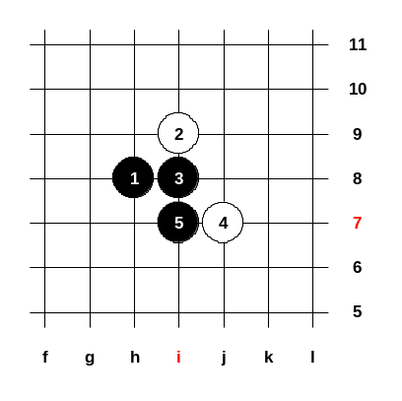
Lets look 4-j7, it is easy. Here are many good 5th moves for black! The easiest ways for black are 5-g8 and 5-i7. Many other 5th moves are possible too. For example j6 or g9 or h10, etc. I will show you the 5-i7 first. Is anyone of you here who studied the last week class? Can you notice the similar position as the last week study? It looks same as if 4-g8 and 5-h7 that we learned last week. Turn your head 90 degrees to the right, and you will understand :))
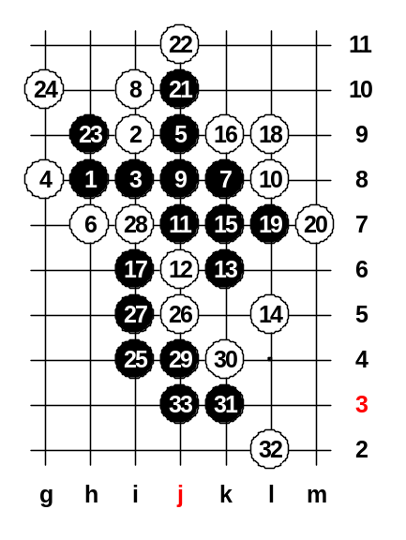
Next Thursday we will look at another 5th move here, 5-g8. Thanks for the coming to study! See you next week! ^^

Feb 3 23:16
Hello everybody! Of course everybody is curious about last week homework answer.
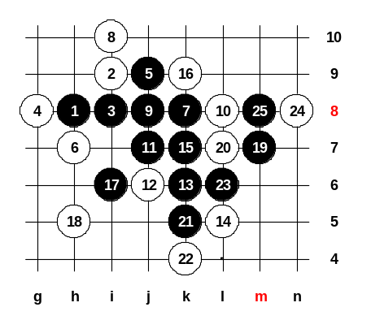
So, we will show you the sure win in the homework now. The black win here is very straight! Of course, white must block 12-j6. Now, white has two choices for 14th move. Which one you want to look first? Ok, it seems that 14-L5 was a puzzle for most of the students. We will check it first. Must 16-k9, of course. The 17-i6 is the key move! If 18-L9, then 19-L7, 20-m7, 21-j10, 23-h9, 25-i4, 26-j5, 27-i5, 29-j4 and win. Ok, we will show it. After 33rd move black has two 4x3 threats.

Feb 3 23:18
Ok, we look 18-h5 now.
Sure, 20-L7. ^^
Play any 24, and then 25-m8 is win.
We will check another 14th move now.

Feb 3 23:19
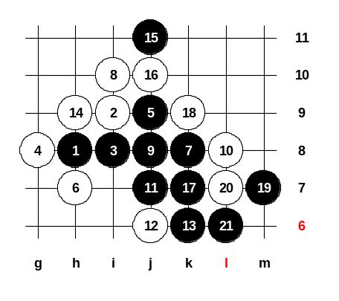
The black win here is very simple! ^^
After this 21st move, the black win is easy.
The m4, m5 is one 4x3 and k5 is other 4x3.
This was the answer for the last week homework.
Any more questions about it?
We will close this board now and continue with another 4th move that we already started looking in last week.

Feb 3 23:21
Today we continue with 4-j7. Last week I said that here black has many ways to play 5th move. However, I suggest 5th moves i7 and g8. In last week I already explained 5-i7 so today i will talk about 5-g8. First we look at the active 6th move - 6-j8.
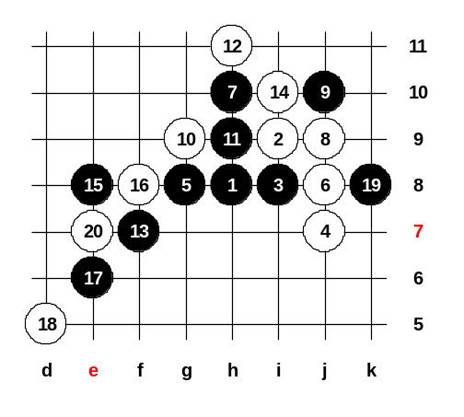
Does anyone know the black steps here? Yes, h10 is the right move! Now white will make moves j9, g9, h11. Here is black win, indeed, but you must know how to play! There is only one way for black win. OK, watch now. I will show you the answer. White seems control the i10 point well, we cannot win without letting white play three there. So, we must give white chance to play three at i10. The 13-f7 !!
And, we must defend at k8. But before that, black must use the fours at e6 and e8.
If black forgets to use these fours, then black maybe cannot win. Now, after 19th move, black can sure win, no matter the white stop. Perhaps we will do that way - we put 20-e7 now and let this be your homework, try to find black win.
Please post your answers to game discussion. Thank you! We will finish today's class, see you next week! ^^

自閉 : Feb 3 23:19
20-G6, 21-D6, 22-C5, 23-D9, 24-H7, 25-H6, 26-F5, 27-E4, 28-G6可否??

自閉 : Feb 3 23:24
20-G6, 21-D6, 22-C5, 23-H5, 24-H7, 25-H6, 26-F9, 27-E10, 28-D7, 29-C6, 30-F5, 我的第二個想法..

自閉 : Feb 3 23:30
21手黑子是G6,手順如下:
黑G6, 白D6, 黑C5, 白H5
黑H7,白H6,黑F9,白E10
黑D7,白C6,黑F5

自閉 : Feb 3 23:32
21手黑子是G6,手順如下:
黑G6,白D6,黑C5,白D9
黑H7,白H6,黑F5,白E4
黑G6 可否??

fivestar : Feb 3 23:36
21-g6, 22-d6, 23-c5, 24-h5 -〉black h7, g9, d7, f5 win.
24-d9, 25-h7, 26-h6, 27-f5, 28-e4, 29-d7, 30-c8-〉black has VCF.
30-g4-〉c6 wins.

萬盤棋 : Feb 8 22:47
It is not easy to find it! But finally I find the answer! ^__^
21-g6, 22-d6, 23-c5.
If (24-h5) then 25-h7, 26-h6, 27-f9, 28-i6, 29-d7, 30-g4, 31-f3, 32-c6, 33-f5, 34-e4, 35-c8, 36-b9, 37-d9, 38-c10, 39-e10.
If (24-d9) then 25-d7, 26-h7, 27-f5, 28-j5, 29-j6, 30-c8, 31-g4, 32-h3, 33-i4, 34-h5, 35-h4, 36 (f4 or j4), 37-g5, 38-g7, 39-g3.
I think it seems the right answer! But I am not sure! If I am wrong, please tell me!

fivestar : Feb 8 23:02
I say wrong〉〈 24 h5-〉h7, f9, d7, f5.

萬盤棋 : Feb 10 04:31
I am too stupid! 〉__〈 In 24-d9! I both play black to attack and white to defense! I find 28-j5 to limits black to develop and don’t let black win easily! But at last! I still find the black sure win here! I am so happy and write it down in Feb 8 22:47. But now I think if white have good move (28-j5) to defense and 26-h7 is no need! White can play 26-f5 and when 27-f9 ,28-j6 can played by white to LET h7 become forbidden point! And at last, I confused still cant find the correct answer here! What stupid am i! Take so much time and still cant find it 〉___〈!

ando : Feb 10 21:17
I am very happy for your good attitude and efforts in solving the homework. The right answer is not always important. Important is a serious and dedicated work on those homeworks. This is how we develop our mind and skill. Good job! ^__^

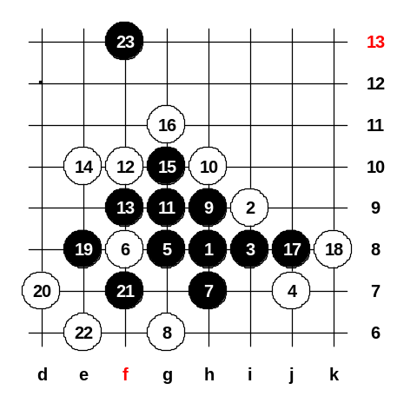
Feb 10 23:22
Thanks to the people who discussed last week homework, no matter if the answer was right or wrong. I appreciate the activity of the people. Today we will finish the studying the 4-j7 first. Here, black seems very strong, however, the win is not simple.
The 8-g6 is a very good stop. Here are two kind of wins. I will show you the shortest win. This 11th move is very unexpected, but it is short win. Another way to win, 11-g9 is very long, over 50 moves. Now, after 12-f10, many of you will recognize the renju problem from "Inside Renju" magazine. Did anyone of you solve this problem already? So...? Any ideas?
No, not f7 but e8. If 20-h11 then 21-e6 and 23-f5. So, 20-d7 is stronger. After 32-f7 white must play e6, otherwise i7 is win. And now, black will win with beautiful move f13. This way of the win I learned 9 years ago from Japanese master Makoto Yamaguchi. Makoto Yamaguchi got the 2nd place in World Championship in 1991.
Any questions about this 4th move? If no, then we close this diagram and continue with other 4th move.

Feb 10 23:34
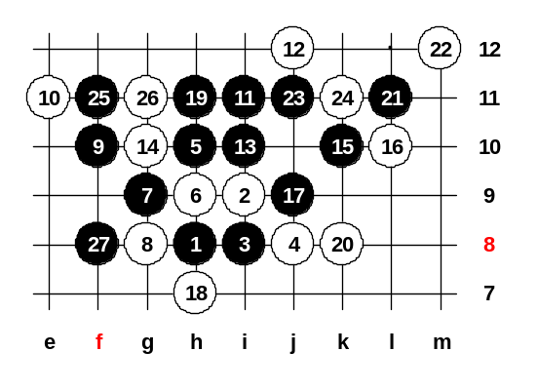
Do you know the best 5th moves here? I believe here are only three choices for 5th move, any other 5th move gives white win, so be careful. The h10 is correct indeed. The best! I believe j9 is not correct. The g9 is all right. And where is the third choice for 5th move? Yes, k7 is right too. ^^ So, h10 is the best, k7 is the second best, and g9 is the third option. So, lets begin. The h10 first. You can tell me white moves, and I best black moves. Ok, we look h9 first, and next we look is h7. The 15-k10 is the key move here. Black wins.

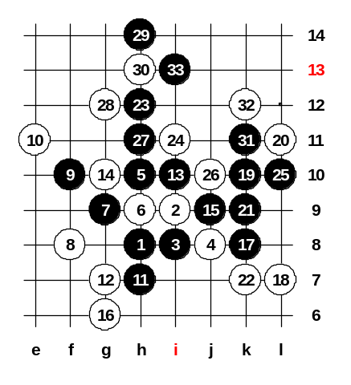
Feb 10 23:36
Lets look 8-f8 now.
The 11th is the key move here.
You can try some white defense here, I will show black steps.
White 12-g7 is the strongest defense, I say.
If 16-k10 then 17-i6.
The 23-h12, very good, black seems to win for sure.

Feb 10 23:06
Move 8-f10. This is your homework. Please prove black win here.
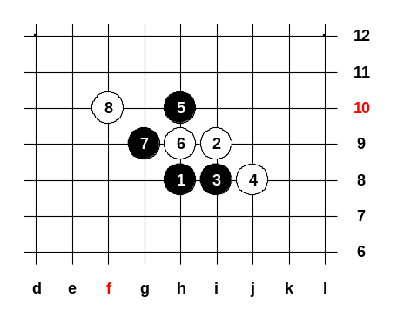
Thank you all for joining the class! ^__^

素早!? : Feb 11 16:15
I Think... 9-F8, 10-E7, 11-G8, 12-E8, 13-G6, 14-G7, 15-H7, 16-F5, 17-I6, 18-J5, 19-J6, 20H6 〉〉21-J10 black Win! (Maybe)

臨風 : Feb 13 09:43
這局與恆星變化相同^^
9-F8, 10-E7, 11-G8, 12-E8, 13-G6, 14-G7, 15-H7, 16-F5, 17-I6, 18-J5, 19-J6, 20H6, 21-I7, 22-K5, 23-I5, 24-I4, 25-K7, 26-L8, 27-K8 兩手四三!

素早!? : Feb 14 14:08
哈哈! 你的答案比我漂亮多了^^~

萬盤棋 : Feb 17 04:42
The moves are the same as mine! And maybe are the correct answer! And I seems no need to type it one more time! ^o^

Feb 17 23:20
Lets look 6-i7 now.
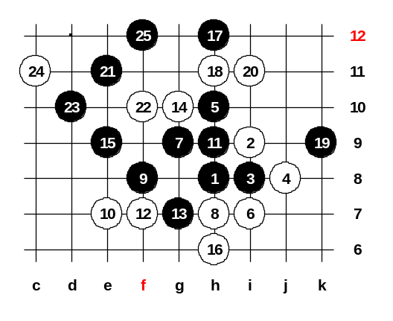
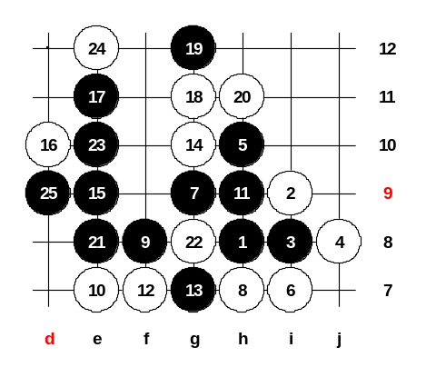
Here, the 7th move is not easy to find if you do not have the book. Does anyone of you know about black win 7th move? Yes, 7-g9 is correct! ^^ The 8-h7 is the strongest white move. Black does not have very straight easy win here, therefore you must learn the black steps carefully. The 11-h9 is the key move. The only way to win. So this is black win, any questions? Ok, we open another diagram to try 16-d10.

Feb 17 23:22
Here, 17-e11 is the right move.
If 18-h11 then 19-e8, 21-c8.
Shall we look at another 5th move now?

Feb 17 23:14
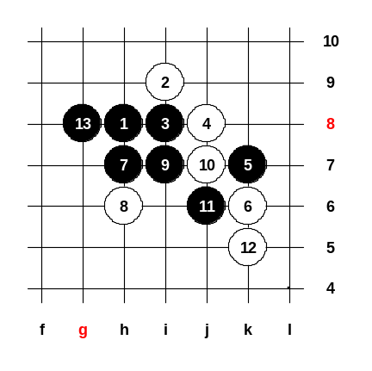
As I told before, the second best 5th move is k7. Here, black attacks in positional style, not very straight. Therefore, it is hard to show you all the ways here. Perhaps we can just play some example moves and you will see the ideas how black attacks. Try some white moves, i play blacks. This time black won quite fast. With this example game, we finish our today's study.

